Problem 1

1. Using **.step** plot 5 complete cycles of the diode current iD(t) when 50Ω≤R≤250Ω .

Diode Current when Ro = 50, 100, 150, 200, 250

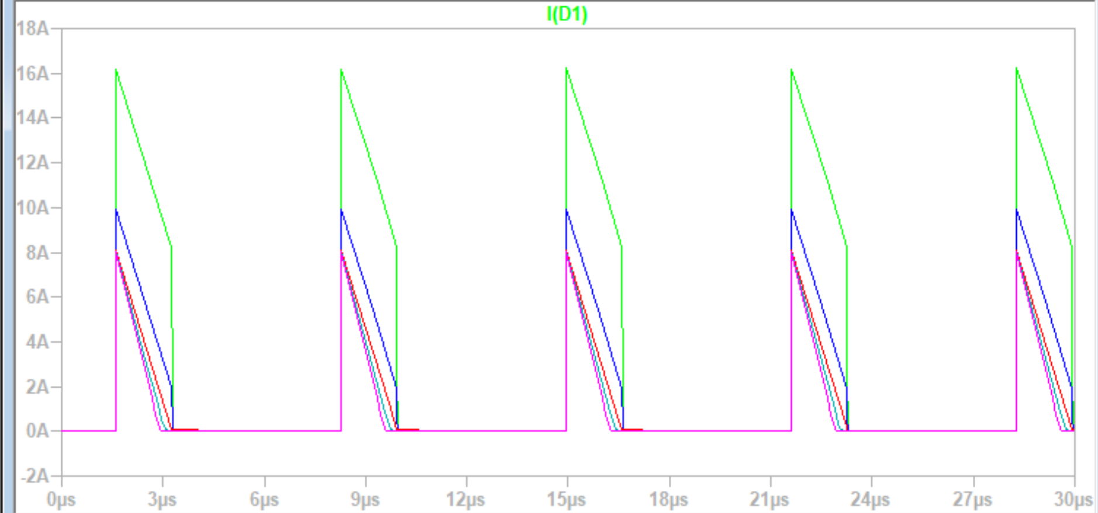

1. In your simulation, determine the value of R that will result in the operation at the boundary between CCM and DCM for the current iD(t).

Ro with sweep through 140, 144, 148, 152, 156, 160

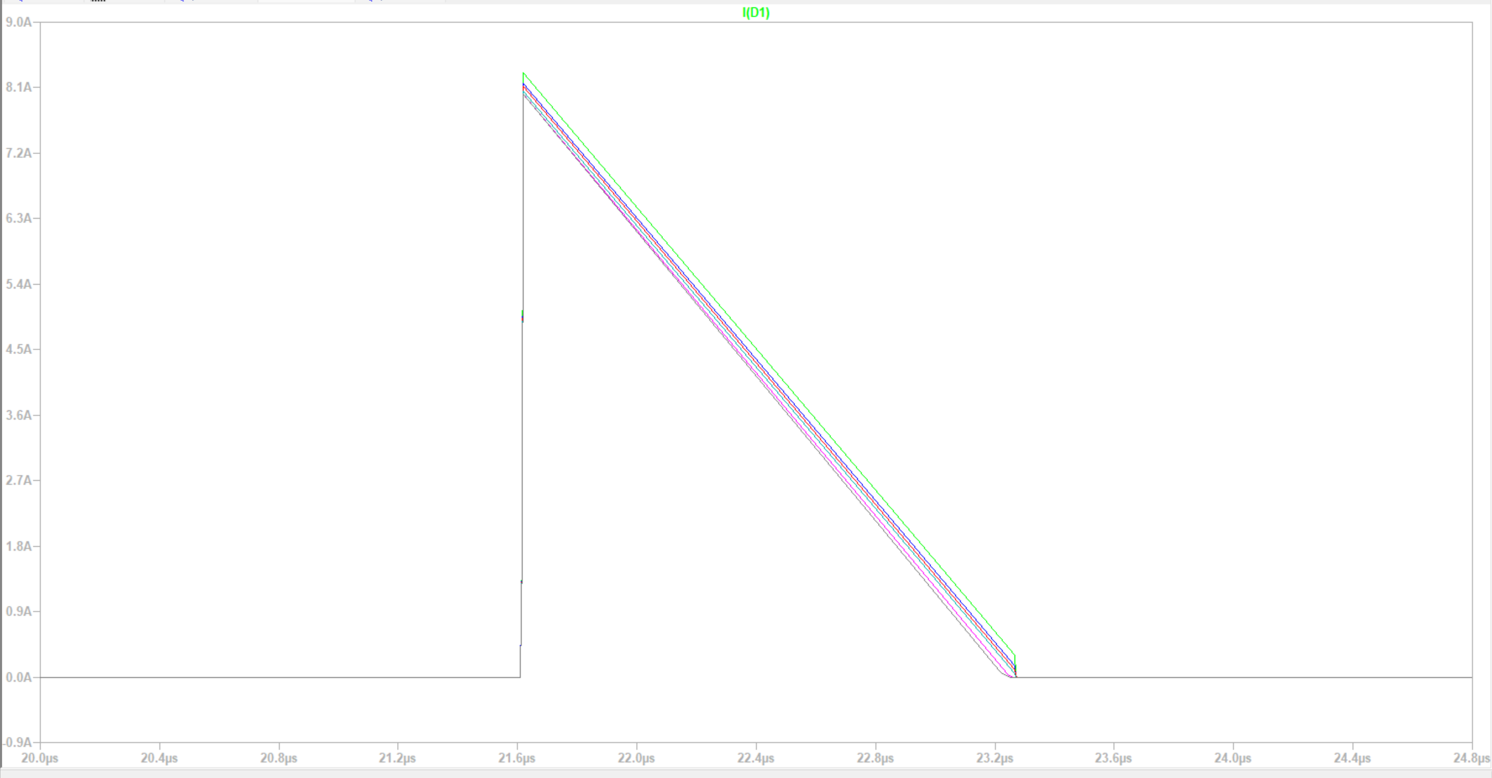

Based on these pictures, Ro =152 is the boundary between CCM and DCM.

1. Plot 5 complete cycles of the currents iL1(t) and iL2 when the converter is operating at the boundary between CCM and DCM, and when the converter has reached periodic steady state.

Problem 3

Use LTSpice to simulate the inverter of [Figure 3.1](https://qee254-pset02-785116.tesla-pages.stanford.edu/sinepwm.html#fig-fastlegslowlegCp) using a sine-triangle intercept PWM modulation.

* You can use a circuit similar to the one shown in [Figure 3.2](https://qee254-pset02-785116.tesla-pages.stanford.edu/sinepwm.html#fig-rectsinmod) to obtain the PWM signals of the fast switching devices (S1 and S2).
* We define k as the *modulation depth*, and it is a parameter that you vary to change the amplitude of the output’s fundamental.
* The parameter values are: Vi=125 V, L=27 μH, C=10 μF, R=3 Ω, and fac=60 Hz.

* Set the frequency of the carrier triangle signal, vtr, to 225 kHz and set k=0.75.
  + Plot the inductor current ix(t), vx(t), and the voltage across the resistive load.

* + Also, plot the FFT of these signals **using at least three full ac cycles** of the corresponding waveforms to obtain the FFT.

As to be expected, Vx has one major peak at 60 hz, and the next major peak is at 225 kHz.

Problem 4

* Use LTspice to simulate an inverter supplying power to the ac line, similar to the one shown in [Figure 4.1](https://qee254-pset02-785116.tesla-pages.stanford.edu/gridtied.html#fig-gridtiedinv). For this problem, make Vac=120 VRMS, 60 Hz
* Implement a hysteretic controller to regulate the inductor current, as demonstrated in [Figure 4.2](https://qee254-pset02-785116.tesla-pages.stanford.edu/gridtied.html#fig-Hystsinemod). The inductor current should be a sine wave in phase with the ac line, with an amplitude of Iac=7 ARMS, and with a *hysteresis band* of Δi=0.5 A. The input voltage, Vi, should be set to 200 Vdc. *One way to establish the hysteresis band is by connecting a couple of resistors with positive feedback between the output and the input of a comparator.*

* Calculate the inductor value required to achieve a maximum switching frequency of fs,max=100 kHz KHz.

In the written part of the hw

Plot the time domain waveform of the output of the full bridge (vx(t)) and the inductor current (iac(t)).

Additionally, plot the FFT of the waveforms. Ensure that at least three full AC cycles are used to obtain the FFT.

